**LAB03 : Data Modeling in Cosmos DB**

This lab is about taking a relational database schema and optimize it for CosmosDB

Our database is for an e-commerce web site that we’re calling WebStore. Here is the relational data model for WebStore in SQL Server:

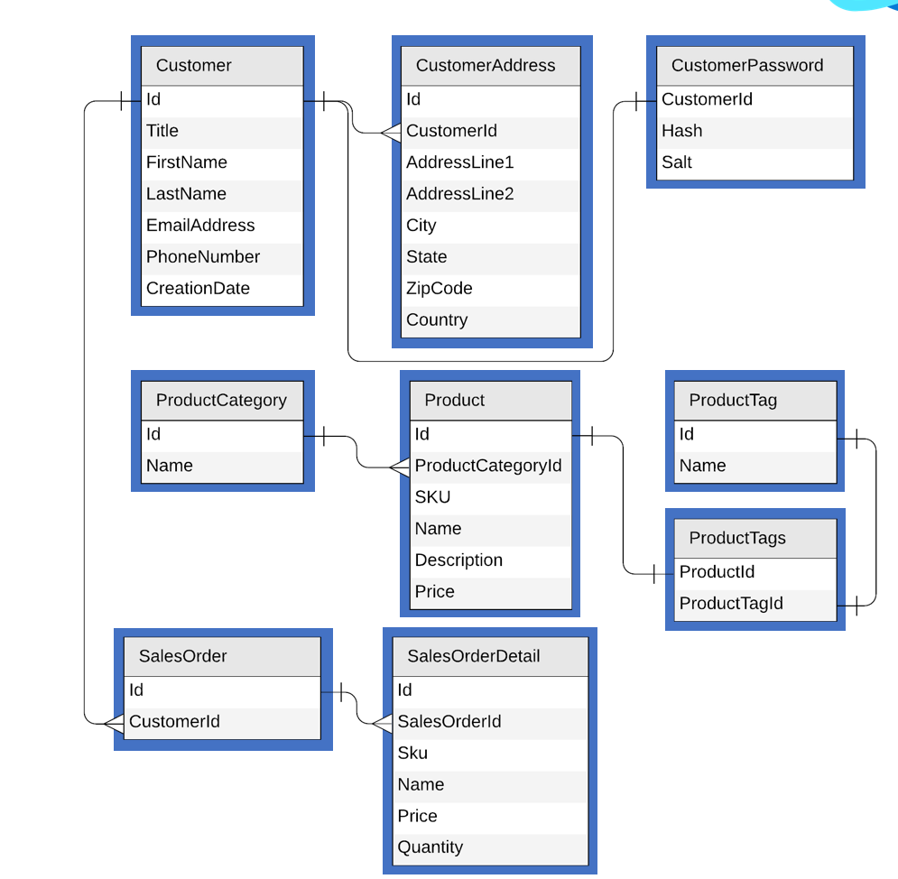

**Login to the virtual machine**

In the Azure Portal, use the Bastion to connect to your team virtual machine (vmteamXX) with the credentials DemoUser / Demo@pass1234567.

**Populate the database**

Click on the “init_cosmos” shortcut on the desktop to initialize your Cosmos DB database and populate it with the initial set of containers

At any time, if you want to return to the original data set, simply click on the shortcut to reset the content of the database.

**Optimize the Cosmos DB data model**

The Cosmos DB database is now populated with 1 container per relational table

Work with the team to conceive the right data model in Cosmos DB, **create** and **optimize** the following queries:

* Get a list of all categories
* Get a list of all products in the category “Clothing, Home & Computers”
* Get a list of sales orders (with details) for Customer #7
* Get the top 2 customers by number of sales

Your task is to come up with the right set of json files that can be imported into your Cosmos DB team database.

Use the json files in the C:\_COSMOSHACK_\labs\LAB03-Data modeling folder as a starting point.

For each optimization you can come up with, fill in the following table to record and compare the performance of your queries.

|  |  |  |
| --- | --- | --- |
| **Query** | **SQL** | **RU/s** |
| List all categories |  |  |
| List all products from category ‘Clothing, Home & Computers’ |  |  |
| List all sales order for customer #7 |  |  |
| Top 2 customers by number of sales orders |  |  |